Answers
Task 1
1. (a) Three types of computer code are given in the table below. For each type of code, state whether it is high-level language code, assembly code or machine code.
Code | Type of code
INPUT Counter  FOR i Counter TO 0 STEP -1 DO  Counter Counter -1  NEXT i | High-level language code
0000001110000101  0000001110000110  0000000000100110  0000000000011011  0000000000100110  0000000001010001  0000000000000000  0000000000000001 | Machine code
INP  loop OUT  STA count  SUB one  STA count  BRP loop  HLP  one DAT 1  count DAT | Assembly code
The code used above is IGCSE pseudocode and Little Man Computer assembly code. The machine code is the Little Man Computer code number as binary. All three programs carry out the same function of counting down from an input number.

(b) A very common computer architecture and instruction set is the 8086 instruction set. Although it was developed for an Intel processor in 1978, it is the basis of the x86 CPU architecture which current Intel processors are based on.
Search for the ‘8086 instruction set’ or the ‘x86 instruction set’. Find at least three instructions that are available in the instruction set and explain what they do. One instruction has been given as an example.
Some websites that may help with researching the 8086 instruction set include:
- https://jbwyatt.com/253/emu/8086_instruction_set.html
- https://en.wikipedia.org/wiki/X86_instruction_listings
- https://onlinelibrary.wiley.com/doi/pdf/10.1002/0471733520.app8
Instruction | Explanation | Example
ADD REG, memory | Adds a memory location to the current value in a register. | ADD AL, 3  This instruction adds 3 to the current value of AL. This is the equivalent of:  AL AL + 3
JMP label | Jumps to another part of the program. | MOV AL, 5  JMP label1  MOV AL, 6  label1:  MOV AL, 7  The instruction MOV AL, 6 won’t be run.
MOV REG, memory | Copy a value in memory into a register. | MOV AL, 5  Moves 5 into the register AL
HLT | Halts the program. In some cases the operating system may do this in order to suspend the system. | HLT
The examples given are just three possibilities. There are 81 instructions in the Intel 8086 instruction set.

Task 2
1. Below are three devices that use embedded systems. Complete the table below the pictures and state how these devices use embedded systems.
 | Used to control the functionality, such as:  Power on/off  Opening and closing the shutter  When to use the flash  Image processing  Provide a user interface
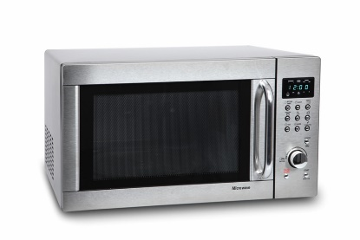 | Used to control the functionality, such as:  Power on/off  Turntable on/off (if present)  Display the timer/menu  Turns the light on inside
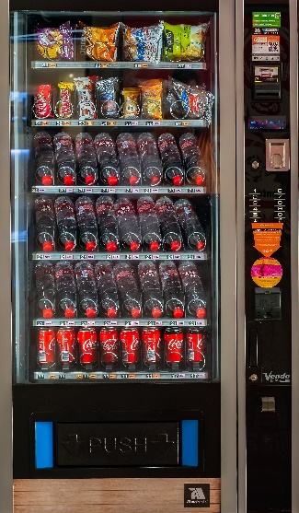 | Used to control which items are released from the vending machine  Coins must be detected and added  The item selected must be checked for its price  If enough money is given, the product is released and any change given  If a card is used, the amount to charge will be sent to the payment merchant (card company).
2. Research other embedded systems that are used today.
(a) List as many as you can below.
Some examples include:
Routers, MP3 players, mobile phones, GPS receivers, printers, washing machines, smart meters, Internet of Things technologies such as CCTV, medical equipment such as heartbeat and blood pressure monitors, PET and MRI scanners.
(b) Select one of the embedded systems you gave in part (a). Research the system then describe the function of the device along with any inputs, outputs, processing and storage required.
Answers will vary depending on which embedded system is chosen.

